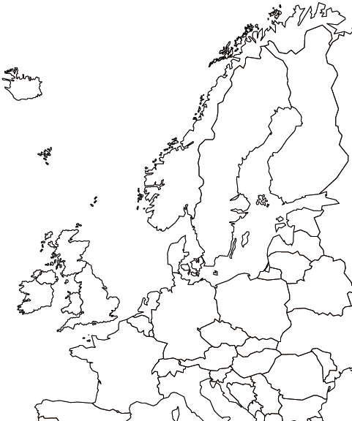
On this map, draw and identify (using the maps on pp. 280 and in other chapters):
In the United Kingdom: Wales, Scotland, Northern Ireland, England. London, Edinburgh, Dublin, Belfast. Thames Riverl
In France: Paris, Lyon, Marseilles, the Seine River, the Loire River, the Rhone River
In Norway, Sweden, Denmark, and Finland: Oslo, Copenhagen, Stockholm, Helsinki
In Germany: Berlin, Hamburg, Munich, the Rhine River, the Elbe River
In the BENELUX countries: Brussels, Amsterdam, the Hague
In Poland: Warsaw, the Vistula River

