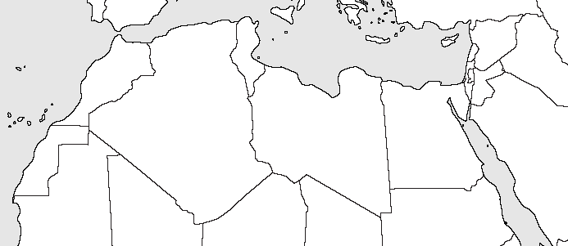

On this map, identify the following countries, cities, and places using your map from Chapter 21:
Morocco
Western Sahara
Tunisia
Algeria
Libya
Egypt
Rabat
Algiers
Tunis
Tripoli
Cairo
Benghazi
Ahaggar Mountains
Atlas Mountains
Qatarra Depression
Lake Nasser
Nile River
Gulf of Sidra
Sinai Peninsula
Mediterranean Sea
Strait of Gibraltar
Sahara Desert

