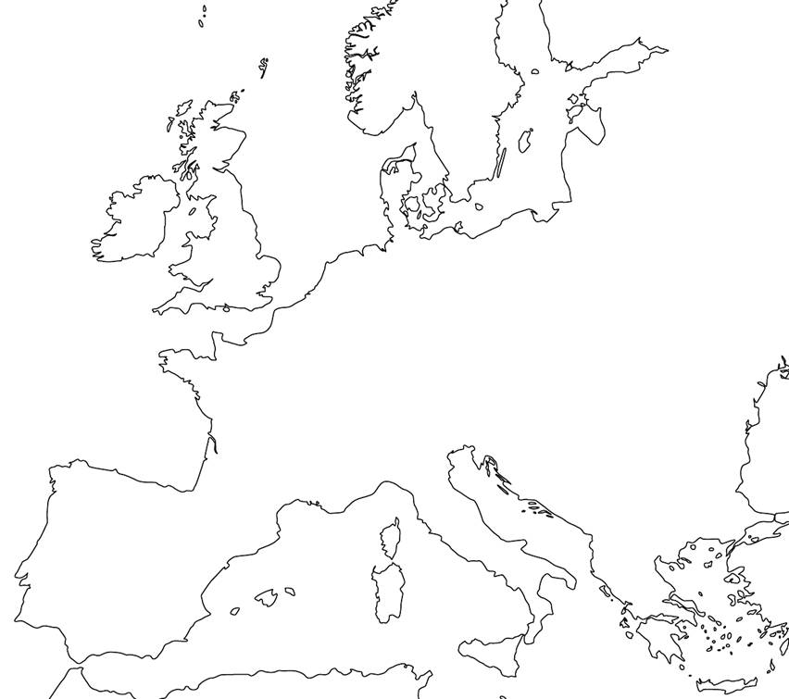

Draw and/or label the following:  
- The boundaries of all the visible European countries   
- The capital cities of all the visible European countries  
- The Rhine, Ebro, Loire, Po, Elbe, Tagus, and Danube Rivers  
- The North Sea, the Baltic Sea, the Adriatic Sea, the Mediterranean Sea, and the Atlantic Ocean  
 See maps on p. S34 and 280/281 in the textbook or any major atlas/maps online