Chapter 23: Eastern Africa (Study Guide handed out May 12th, Test on ALL of Africa, May 15th)
1. The two major valleys of Eastern Africa are the ___________________________ Valley and the
_____________________________ Valley.
2. Near both valleys, numerous ______________ have erupted including the highest mountain in Africa at
19,341 ft, Mt. ___________________________________.
3. The ______________ Nile beings in the highlands of Ethiopia while the ______________________ drains from Lake Victoria through Lake Albert. The White Nile almost ends in South Sudan when it passes through a series
of wetlands called the ____________________.
4. The two main influences on the climates of East Africa are ________________ and variations in
____________________.
5. Because the weather is often unpredictable, there have been a number of major _____________________ in East Africa in recent decades.
6. Part of the reason that the large grasslands of East Africa were never replaced with ranches was due to the ___________________________, which can cause sleeping sickness.
7. Rather than written records, most early East African civilizations kept ________________ histories that were transmitted by telling stories.
8. The __________________ language comes from traders along the East African coast who incorporated Arabic words into traditional languages.
9. The only country that remained largely free of colonial rule in East Africa was __________________________.
10. Most traditional religions of East Africa are ____________________ in that they believe the natural world contains spirits.
11. Most people in East Africa are still subsistence farmers, but some can earn more by gathering local
plants such as _______________ in Sudan, which comes from the sap of acacia trees and is used in many candies and medicines.
12. Because of the many animals, cooler temperatures in the highlands, major beaches, and interesting cultures, East Africa has high potential to attract _________________________ to visit.
13. Conflict between different ethnic groups within countries has resulted in a number of civil and
international conflicts throughout East Africa including the 1994 ______________________ in Rwanda when the Tutsi people were nearly wiped out by the Hutu.
14. Somalia has been the site of much fighting between different ______________ rather than different groups.

Identify the following countries and features:
Somalia
Ethiopia
Sudan
South Sudan (note: not in your textbook, but you can figure out where it is!)
Kenya
Rwanda
Democratic Republic of the Congo
Uganda
Tanzania
Eritrea
Djibouti
Zanzibar Island
Nairobi
Lake Victoria
Nile River (draw it in)
Kampala
Mogadishu
Addis Ababa

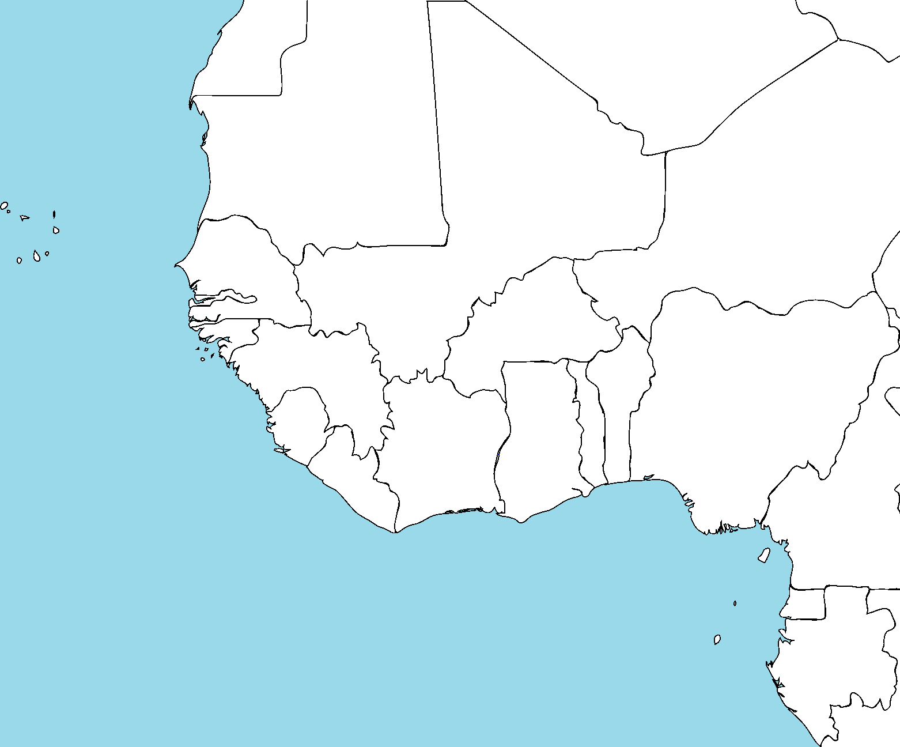
Identify all the countries shown here in Western Africa as well as the following cities/features:
The Niger River
Timbuctou
Lagos
Abidjan
Dakar
Cape Verde

