Chapter 20 Key Points
Geography of Region: Mostly arid to semi-arid, with some fertile areas in river valleys (Jordan esp.) and along the coastline; Rift Valley dominates physical features, though high mountains in Lebanon and Turkey
History (see pp. 454-455)
Military Conflicts
- 1947-1948: Israel and Palestine gain independence from Britain; Israel immediately attacked by surrounding Arab countries, but fights back and stays independent, even gaining some formerly Palestinian territory
- 1956: Israel, along with Britain and France, invades Egypt to try to control the Suez Canal
- 1967: Israel, threatened by Egypt blockading key straits and mobilizing army, pre-emptively attacks and defeats Egypt, Syria, Iraq, and Jordan in 6 days; Israel gains much territory (see below)
- 1973: Egypt, angry at losing, launches surprise attack with aid of Soviet Union and Syria. Israel manages to repel attacks and gains ground before war ends with US and Soviet intervention
-1982: Israel, angry at Palestinian terrorists using Lebanon as a haven, invades Lebanon, but eventually withdraws
Territory Occupied by Israel after 6-Day War
- Gaza Strip (evacuated recently; home to millions of Palestinians and now controlled by Hamas)
- Golan Heights (why would Israel want to hold onto this area for strategic military reasons?)
- Sinai Peninsula (returned to Egypt in 1979 peace treaty)
- West Bank (partially occupied today; exact boundary a matter of dispute)
- Jerusalem—still considered capital by both Jews and Palestinians both secularly (for political reasons) and religiously; very difficult to resolve this issue (though can you think of something?)
Israel Today
- Parliamentary democracy (Parliament = Knesset)—although (somewhat similar to Italy) many different political parties, forcing parties to ally with each other in coalitions, leading to fractured politics
- High-tech economy, high amount of religious tourism (note that other countries in area are far more dependent on tourism in their economy and can suffer more during uncertain times)
Turkey Today
- Major center for textile production (Turkish cotton) plus industrial production in general
- Minority groups (Armenians and Kurds) have suffered in past and claim continued persecution
- Current government is democratic, but has authoritarian tendencies and is openly Islamic (change from previous years of all-secular government—your book is WRONG/behind the times on this)
Rest of Region Today
- Many cities still suffer (and are currently suffering) from wars and conflict—Beirut in Lebanon, Nicosia in Cyprus, and currently Damascus in Syria
- A number of refugee problems still remain, especially Palestinians outside of Palestine in Jordan and Lebanon (this has a destabilizing effect on these countries—why?)
- Lebanon is still very fragile politically and divided between Shi’a, Sunni, and Christian areas
- Subject periodically to very big earthquakes thanks to the divergent rift valley
-Cyprus is urrently divided with Greek part (South) and Turkish part (North) since 1974 invasion by Turkey; Implications for current foreign policy: Cyprus has joined EU, but the Turkish area is isolated

Potential Short Answer Questions:
- How have the boundaries of Israel changed over time and why? Identify at least three key moments when Israeli territory shifted. What have been some of the implications of these shifts in territory for the people in those areas in the past and today?
- What countries of the Middle East have suffered from warfare in recent years (i.e. post World War II, 1945)? Identify at least three countries that have experienced warfare and explain both the causes of the wars and the effects the war had on the people who live there.
- Compare and contrast the older cities of the Middle East centered around the Eastern Mediterranean with the newer cities centered around the Persian Gulf. How are they similar, how are they different, and what explains those differences?
- Consider the importance of oil and water in the Middle East. Explain how each resource is important in its own way and which countries in the Middle East tend to have more or less of these resources. Finally, for each resource discuss the potential for conflict over control of each resource and provide one example for each.
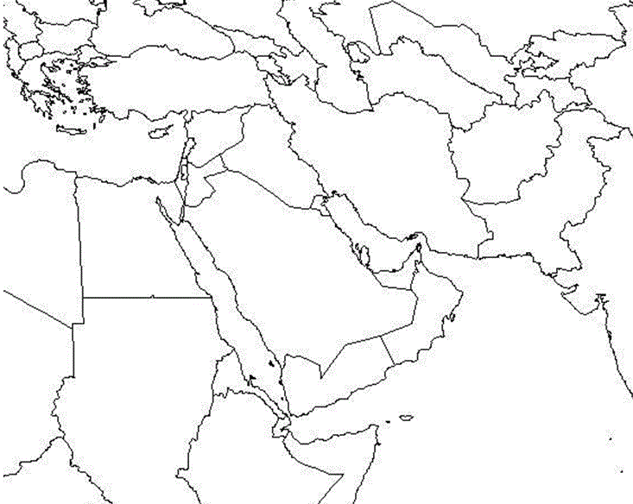
This blank map is for if you want to quiz yourself.

