Chapter 24 Study Guide: Handed out 5/14
1. Much of Southern Africa consists of a large plateau that slopes down to a narrow coastal plain. The edges of the plateau form a large _____escarpment_____, a cliff face at the edge of the plateau. The largest escarpment in Southern Africa forms part of the ____Drakensberg____ Range of mountains. In addition, as water drops down the escarpment it forms many ______waterfalls_______ and as it erodes it forms many ______canyons_____.
2. Madagascar is known for its ______biodiversity______, the high amount of different types of plants and animals in the area including lemurs.
3. A cold water current current influences the climate of Southern Africa, which makes the air around the Atlantic coast very dry and forms the __________Namib________ Desert. The ____Kalahari____Desert is located in the central part of the Southern African plateau, which eventually merges into the grasslands of the _______veld_______ in South Africa.
4. South Africa has a number of energy reserves and resources, with many diamonds and gold mines in a region called the ___rand____. Zambia is known for its _________copper________ deposits.
5. Dutch settlers who came to South Africa as farmers were known as Boers but called themselves ____Afrikaners____. Later, Great Britain took over the Cape area after a bloody war.
6. When the British pulled out, the white South Africans set up a policy of ____apartheid___ or separateness, which enforced racial segregation. Other countries disliked this and began to place _____sanctions____ on the South African government. The ___African National Congress____, led by Nelson Mandela, opposed the policy of apartheid and eventually in 1990 succeeded in ending it. There are still a number of challenges remaining from its legacy though including high levels of poverty and segregated housing patterns.
7. Southern Africa has a large percentage of its population infected with ___HIV____, the virus that causes AIDS, which is negatively affecting the quality and length of life.

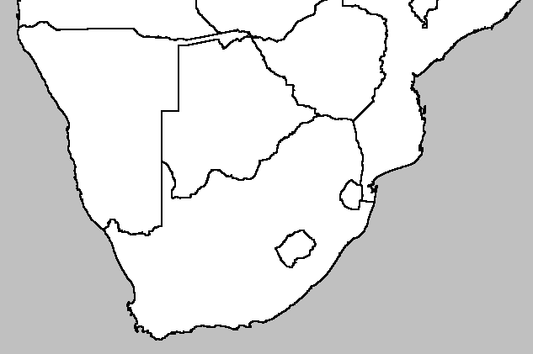
Identify the following on this map:
South Africa, Namibia, Botswana, Zimbabwe, Mozambique, Lesotho, Swaziland

Orange River, Limpopo River, the Drakensberg Range, the Namib Desert, the Kalahari Desert, the Veld, Zambezi River, Cape Town, Johannesburg
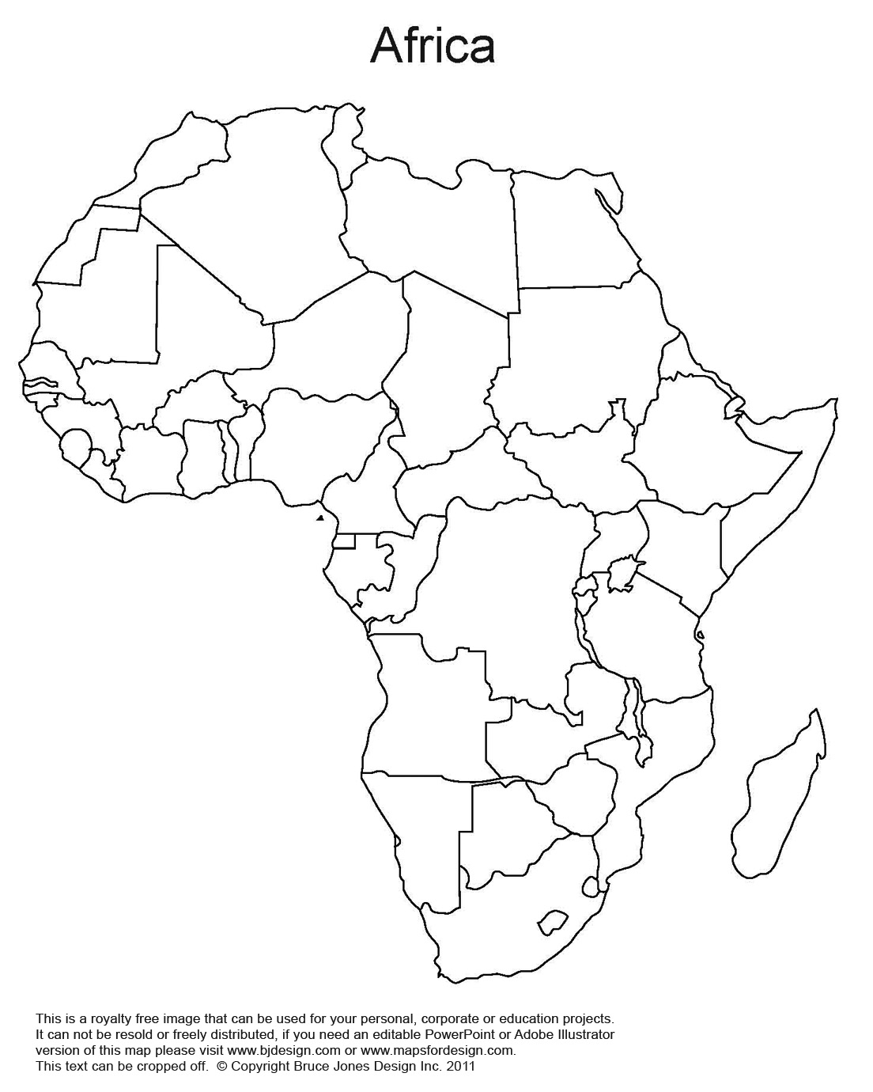
Be able to identify the following features:
Lake Victoria, Niger River, Nile River, Congo River, Orange River, Cape Town, Nairobi, Lagos, Dakar, Cairo, Algiers, Addis Ababa, Indian Ocean, Atlantic Ocean
Make Sure to Know the Following Countries for the Test:
Egypt, Libya, Algeria, Tunisia, Morocco, Mali, Chad, Sudan, South Sudan, Ethiopia, Somalia, Kenya, Uganda, Rwanda, Tanzania, Democratic Republic of the Congo, Mozambique, Zimbabwe, South Africa, Namibia, Botswana, Angola, Gabon, Central African Republic, Zambia, Madagascar, Nigeria, Ghana, Cote d’Ivoire, Liberia, Sierra Leone, Burkina Faso, Senegal, Mauritania

