DIRECTIONS: Read the following excerpts from two speeches given recently by Israeli and Palestinian leaders. Then, answer the questions below the speeches in complete sentences. This is due at the start of class on Friday, 4/25.
“Ladies and Gentlemen…The core issue here is that the Israeli government refuses to commit to terms of reference for the negotiations that are based on international law and United Nations resolutions, and that it frantically continues to intensify building of settlements on the territory of the State of Palestine…This policy, which constitutes a breach of international humanitarian law and United Nations resolutions, is the primary cause for the failure of the peace process, the collapse of dozens of opportunities, and the burial of the great hopes that arose from the signing of the Declaration of Principles in 1993 between the Palestine Liberation Organization and Israel to achieve a just peace that would begin a new era for our region.”
Palestinian Liberation Organization President Mahmoud Abbas at a speech to the United Nations in September 2013
1. According to Abbas, what is the most important issue for the Palestinians when negotiating with the Israelis?
Why do you think this issue is particularly important to the Palestinians?
2. What specific arguments does Abbas make for why the settlement issue has been a sticking point in previous negotiations?

Ladies and gentlemen, peace is Israel’s highest aspiration. I’m prepared to make a historic peace with our Palestinian neighbors –a peace that would end a century of conflict and bloodshed. Peace would be good for us. Peace would be good for the Palestinians…. Just as Israel is prepared to recognize a Palestinian state, the Palestinians must be prepared to recognize a Jewish state. President Abbas, recognize the Jewish state, and in doing so, you would be telling your people, the Palestinians, that while we might have a territorial dispute, the right of the Jewish people to a state of their own is beyond dispute.
Israeli Prime Minister Benjamin Netanyahu
3. What, according to Netanyahu, is Israel’s foremost priority in negotiations with the Palestinians? Why do you think he places such an emphasis on this topic?

4. What do you think Netanyahu means when he says that “Peace would be good for us. Peace would be good for the Palestinians”? If peace would be good for both of them, why have they not been able to reach a pace agreement?

5. Based on what you read above and other information that you may have learned, do you think Israeli and Palestinian goals are incompatible for peace? Why or why not?

Section 3 Chapter 20 + Case Study of Israel and Palestine Study Guide
1. Many countries in the Middle East receive ____________ from other countries, with the United States and Saudi Arabia being among some of the most generous donors.
2. _____________ is the most highly developed economy in the Mediterranean Area with a large portion of its income coming from ____________ cutting.
3. Many areas of the Eastern Mediterranean have suffered through _________________ recently including Cyprus in 1974, Lebanon in 1975-1990, and Syria from 2012 to the present.
4. The main environmental concern for the Eastern Mediterranean countries is a lack of _________________________.
5. Israel has a _______________ form of government. The Palestinians are currently divided between two governments
with __________ in control of the Gaza Strip and ______________ in the West Bank (though watch the news on this!).
6. At least 4 major issues continue to prevent an Israeli-Palestinian peace agreement.
a. One is what to do about the Israeli _______________ scattered throughout the West Bank.
b. Another is how to divide up the city of _________________ since both sides claim it as their capital.
c. How to resolve water-related issues from the shared ____________ beneath the ground.
d. Whether or not to allow Palestinian _______________ to return back into Israel.
e. Palestinian recognition of Israel’s cultural identity as a ____________ country.
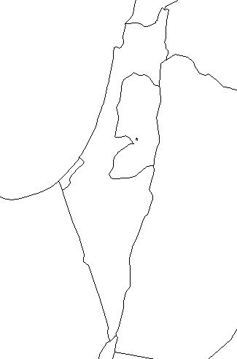
Identify the following features on the map (see p. 453):
Israel
The West Bank
The Gaza Strip
The Mediterranean Sea
Jordan
Syria
Egypt
Jerusalem
Draw the Jordan River, the Dead Sea, and the Sea of Galilee
North

