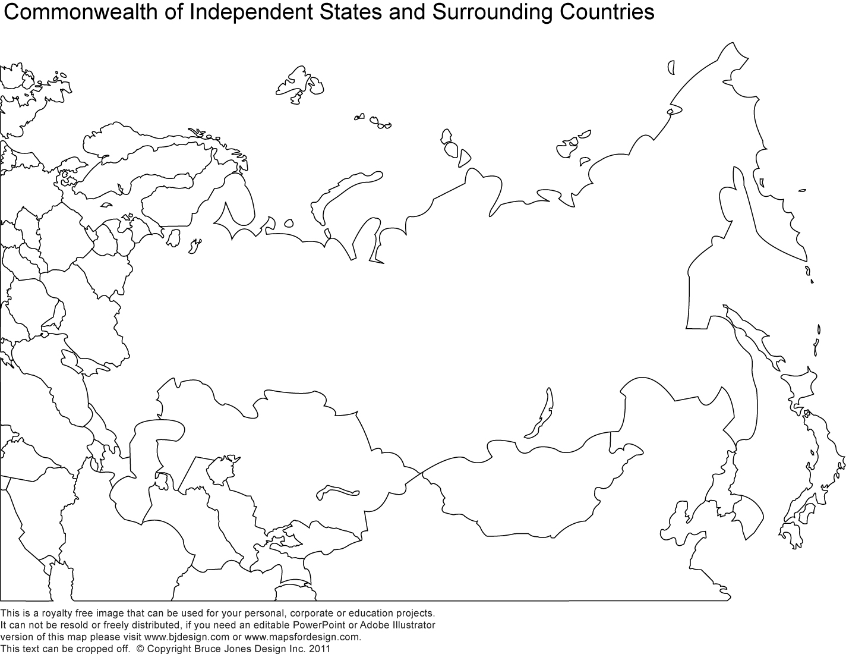

Identify the following locations on this map (due at start of class by MONDAY March 17th; finish for homework if you do not finish in class):   
Look in the book (or online) for the maps; Chapter 17 has some as does the start of the book   
**Country Names**: Georgia, Armenia, Azerbaijan, Ukraine, Belarus, Russia, Kazakhstan, Uzbekistan, Kyrgyzstan, Turkmenistan, Tajikistan  
**Bodies of Water**: The Caspian Sea, the Black Sea, the Aral Sea, Lake Baikal, Lake Ladoga (need to look carefully), the Arctic Ocean, the Sea of Okhotsk, Lake Balkash  
**Cities**: Novosibirsk, Vladivostok, St. Petersburg, Sochi, Volgograd, Almaty, Samarkand, Astana, Moscow, Baku, Tashkent, Kiev, Minsk